**HELLO AGAIN FROM AVI FRESH!**

The dining services team is excited to welcome you back as we start a new school year. We are looking forward to your arrival and are honored to serve the students, faculty and staff at Butler Tech.

We’ve spent the summer creating new recipes and preparing for your return to school. We have many exciting programs and menus planned!

Menus for your school are available at Butlertech.org and also now through the SchoolCafé App!

If you should have any questions or special requests regarding food sensitivities, please contact us and we’ll be glad to work together.

We’re grateful for the opportunity to serve you!

INTRODUCING SCHOOLCAFÉ

View our school menus through SchoolCafé!

SchoolCafé provides access to view   
daily features and nutritional information   
at your fingertips!

Visit the site or download the SchoolCafé app to your phone today!

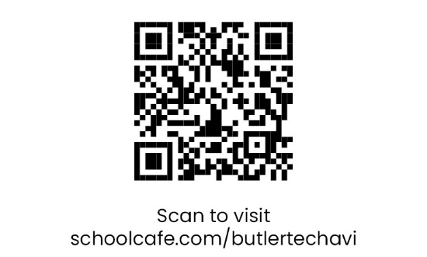

**WE’RE HERE TO SERVE YOU!**

**Jeffery Harrison**

Resident Director

Phone: 513-645-8316 or

Email: Jeffery.Harrison@butlertech.org

|  |  |
| --- | --- |
| **BREAKFAST** | $2.55 *7:00 a.m. – 8::00 a.m. in the cafeteria* |
| **LUNCH** | $4.00 |
| **EXTRA MILK** | $1.00 |

**SCHOOL LUNCH ACCOUNTS:**

**An easy and convenient way to purchase school meals!**

|  |  |  |
| --- | --- | --- |
| **CREATING ACCOUNTS** | **FUNDING ACCOUNTS** | **MEAL ASSISTANCE** |
| Visit PaySchoolsCentral.com website to create your student’s your student’s account. | Fund through the account website or send your student with a check made out to Butler Tech or cash for their account. | Visit PaySchoolsCentral.com website for a free or reduced application. |

This institution is an equal opportunity provider.